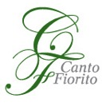

Children and youth art contest The Hanseatic Way

Children and youth art contest The Hanseatic Way is part of musical and educational project The Hanseatic Way: A Musical Journey Through a Shared Past, supported by Creative Europe programme of the European Union and implemented by early music ensembles Canto Fiorito (Lithuania) and Musica Antiqua Salzburg (Austria) in collaboration with ERP Music management company (Estonia).

We are inviting children and youth from the former Hanseatic countries to take part in this huge international project and become co-creators of the videofilm, which will be screened during 8 concerts of the project in 7 European countries as the part of important musical and cultural festivals! This contest is a great opportunity for children to explore the culture of Hanseatic countries, participate in a large-scale collaborative creation that unites disciplines of history, music and art, and receive international visibility as well as compete for prizes.

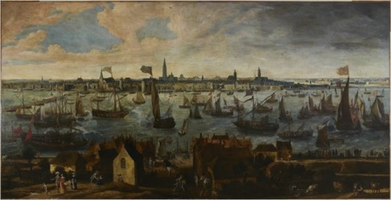
Antwerp, XVII c.

The project

The Hanseatic League was a commercial confederation of merchant guilds and their market towns. It dominated maritime trade in the North and Baltic Seas between 1300 and 1700, with trade routes that extended from London to Tallinn, enabling vast commercial and cultural exchange. Via a widely know historical phenomena of the Hanseatic League, this project aims to raise the interest of the contemporary society and especially of children and youth in a shared European cultural heritage.

A specially created concert program, which will be performed in 7 European countries by early music ensembles Canto Fiorito and Musica Antiqua Salzburg, represents composers from each Hansa country chronologically, in a simulated journey through space and time – through XVI-XVII centuries, starting in England, passing through Belgium, Netherlands, Germany, Scandinavia, Poland and finally reaching the Baltic states. The programme includes widely known composers such as Heinrich Schütz from Germany, William Byrd from England, Orlando di Lasso from Belgium, and great, but less know composers from smaller European countries like Bartlomiej Pekiel from Poland or Giovanni Battista Cocciola from Lithuania. The music from Hansetic countries will be performed with historical instruments and following the aesthetical requirements of those times – in renaissance and baroque styles.

Children and youth are invited to join this imaginable journey through time and space by researching historical images of the Hanseatic cities of their countries created in XV-XVII centuries, and then creating their own artworks inspired by the historical ones. The selected artworks will become the part of a videofilm, screened during the concerts!

Terms and conditions

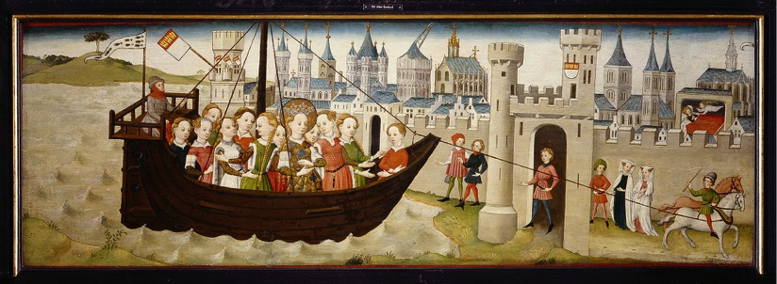
Köln, XV c.

- The Contest is open to all children and youth aged 12-17, living in the cities, where the project concerts will take place: Vilnius, Kaunas, Rostock, Tartu, Brighton, Vienna and Riga.

- The artworks presented to the contest should be related to the Hanseatic League theme.

- Participants are invited to draw or paint images, landscapes, life scenes, maps, etc. of Hanseatic cities of their own country in medieval, renaissance and early baroque styles or using the elements of these styles (the list of cities of the Hanseatic League could be found here: https://en.wikipedia.org/wiki/Hanseatic_League

- Participants can use and revise the existing historical images of Hanseatic cities, created in XV-XVII centuries, or their fragments by colouring them or transforming otherwise, adding characters and stories, using means of collage, animation or other techniques.

- Participants are invited to use their creativity and imagination with respect to the historical material and historical styles, as the means to connect the past and the present.

- Participants can use the historical images of Hanseatic cities downloaded from the website of the ensemble Canto Fiorito: http://cantofiorito.lt/CHILDREN-AND-YOUTH-ART-CONTEST-THE-HANSEATIC-WAY-909.html or use other historical images created in XV-XVII centuries. In the case when artworks are created referring to the historical images not from Canto Fiorito website, participants will be asked to send these images to the organisers of the Contest.

- After finishing their artwork, participants are asked to scan it in high resolution and send it to e-mail address: administration@cantofiorito.lt

- Children from Lithuania are asked to send their works till the 7th May 2018,
Paintings from Estonia must reach us till 1st of June 2018.
Children from Great Britain, Austria and Latvia are asked to send their works till the 1st of October 2018.
Together with the painting please indicate the name, family name; age; country and city of residence also e-mail address of the author. In case the digital data exceeds 10 MB, please use www.wetransfer.com to send the image.

- Each participant may submit only one piece of artwork to this contest.

- Each participant agrees to transfer, at no additional cost, to the organisers of the Contest his/her rights to the artwork submitted for the Contest, without any territorial or time limitations, for all forms of exploitation within the context of the project The Hanseatic Way, such as: copying; printing; distributing; publishing; modifying; altering; transferring; storing in any form of storage; using in public presentations and/or exhibitions; displaying – all of the above by whatever means and in any form and format.

- The selected artworks and the names of their authors will be used in a videofilm screened during the concerts of the concert tour “The Hanseatic Way: a Musical Journey Through the Shared Past” in Vilnius, Kaunas, Rostock, Tartu, Brighton, Vienna and Riga (one more concert to be confirmed).

- The selected artworks will be published on the website of the project “The Hanseatic Way: a Musical Journey Through the Shared Past” (under construction).

- When possible, participants of the Contest will be invited to the concerts and called to the stage at the end of the concert.

- The authors of the best artworks will receive special prizes: one Kindle reader, two books on art and souvenirs in every city, where the contest and concerts take place.

- For inquiries, please contact administration@cantofiorito.lt

Let’s revive the culture of the Hanseatic League together!

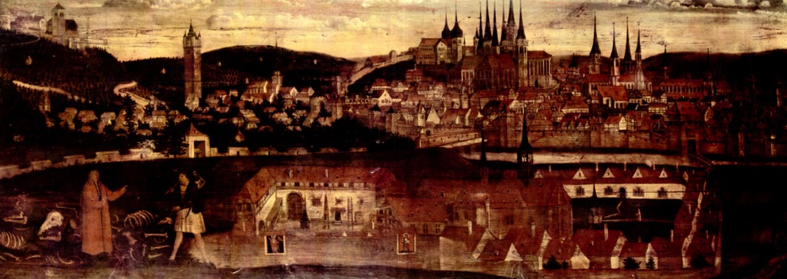Erfurt, XVI c.

